Learning Outcome
In this section, we will read about:
- Serverless Architectures
- What is the cloud provider’s role in serverless?
- Why use serverless architectures?
- How does Serverless Architectures Work?
- Function-as-a-Service (FaaS)
- Popular Serverless Platforms
- Serverless Architecture Use Cases
- Advantages of using serverless architecture
- Limitations serverless architecture

Serverless Architectures
A serverless architecture is a way to build and run applications and services without having to manage infrastructure. It is a software design pattern where applications are hosted by a third-party service, eliminating the need for server software and hardware management by the developer. Applications are broken up into individual functions that can be invoked and scaled individually.
What is the cloud provider’s role in serverless?
Under a serverless model, a cloud provider runs physical servers and dynamically allocates their resources on behalf of users who can deploy code straight into production.
Serverless computing offerings typically fall into two groups, Backend-as-a-Service (BaaS) and Function-as-a-Service (FaaS).
BaaS gives developers access to a variety of third-party services and apps. For instance, a cloud-provider may offer authentication services, extra encryption, cloud-accessible databases, and high-fidelity usage data. With BaaS, serverless functions are usually called through application programming interfaces (APIs).
More commonly, when developers refer to serverless, they’re talking about a FaaS model. Under FaaS, developers still write custom server-side logic, but it’s run-in containers fully managed by a cloud services provider.
The major public cloud providers all have one or more FaaS offerings. They include Amazon Web Services with AWS Lambda, Microsoft Azure with Azure Functions, Google Cloud with multiple offerings, and IBM Cloud with IBM Cloud Functions, among others.
Some organizations choose to operate their own FaaS environments using open source serverless platforms, including Red Hat® OpenShift® Serverless, which is built on the Knative project for Kubernetes.
Why use serverless architectures?
By using a serverless architecture, developers can focus on their core product instead of worrying about managing and operating servers or runtimes, either in the cloud or on-premises. This reduced overhead lets developers reclaim time and energy that can be spent on developing great products which scale and that are reliable.
How does Serverless Architectures Work?
Servers allow users to communicate with an application and access its business logic, but managing servers takes considerable time and resources. Teams have to maintain the server hardware, take care of software and security updates, and create backups in case of failure. By adopting serverless architecture, developers can offload these responsibilities to a third-party provider, enabling them to focus on writing application code.
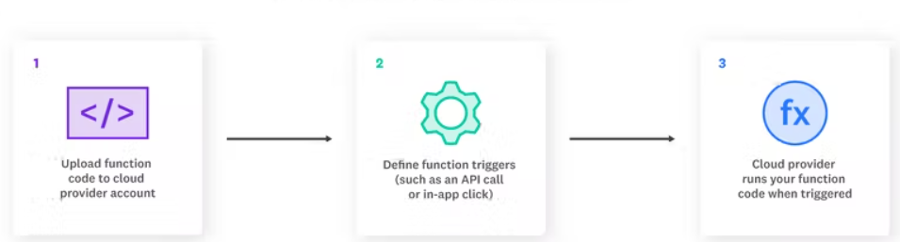
Image 1- Serverless functions work
Reference: https://www.datadoghq.com/knowledge-center/serverless-architecture/
Developers rely on serverless to execute specific functions. Because of this, cloud service providers offer Functions as a Service (FaaS). The steps to writing a function and execute it in a serverless way are following-
- The developer writes a function. This function often serves a specific purpose within the application code.
- The developer defines an event. The event is what triggers the cloud service provider to execute the function. A common type of event is an HTTP request.
- The event is triggered. If the defined event is an HTTP request, a user triggers the event with a click or similar action.
- The function is executed. The cloud service provider checks if an instance of the function is already running. If not, it starts a new one for the function.
- The result is sent to the client. The user sees the result of the executed function inside the application.

Fundamental Concepts in Serverless Architecture
Although serverless architecture eliminates the need for server management, there’s still a steep learning curve, especially if you’re chaining multiple functions together to create complex workflows in an application. It can therefore be helpful to familiarize yourself with these fundamental serverless terms:
- Invocation
A single function execution.
- Duration
The time it takes for a serverless function to execute.
- Cold Start
The latency that occurs when a function is triggered for the first time or after a period of inactivity.
- Concurrency Limit
The number of function instances that can run simultaneously in one region, as determined by the cloud provider. A function will be throttled if it exceeds this limit.
- Timeout
The amount of time that a cloud provider allows a function to run before terminating it. Most providers set a default timeout and a maximum timeout.

Function-as-a-Service (FaaS)
Function-as-a-Service (FaaS) is an event-driven computing execution model where developers write logic that is deployed in containers fully managed by a platform, then executed on demand.
In contrast to BaaS, FaaS affords a greater degree of control to the developers, who create custom apps rather than relying on a library of prewritten services.
Code is deployed into containers that are managed by a cloud provider. Specifically, these containers are:
- Stateless, making data integration simpler.
- Ephemeral, allowing them to be run for a very short time.
- Event-triggered, so they can run automatically when needed.
- Fully managed by a cloud provider, so that you only pay for what is needed, not always-on apps and servers.
Using FaaS, developers can call serverless apps through APIs which the FaaS provider handles through an API gateway.

Popular Serverless Platforms

Serverless is not only about a single service but a host of services that enable us to benefit from serverless architecture. There are quite a few cloud-services vendors available today that boast of a very mature catalog of serverless services: -

Serverless Services on AWS

The most important service in the catalog of serverless services on AWS is the FaaS service Lambda. AWS Lambda is a serverless compute service that lets us run our code without provisioning or managing servers. It allows us to write the Lambda functions in any of the popular languages like Node.js, Python, Go, and Java. We can simply upload our code as a ZIP file or container image.

Hence, we get to use precise computation power for any scale of traffic. Moreover, AWS provides a host of other services for our serverless application. For instance, Amazon EventBridge for building event-driven applications. Amazon API Gateway to create, publish, maintain, monitor, and secure our APIs. Amazon S3 to store any amount of data with scalability and availability.

Serverless Services on GCP

Similarly, within the offerings of GCP, Cloud Functions is the key serverless product. Cloud Functions is a scalable pay-as-you-go FaaS to run our code with no server management. It automatically scales our application on the load. Further, it provides integrated monitoring, logging, and debugging. Moreover, it features built-in security at the role and per-function levels.

Another key offering from GCP is the PaaS product App Engine. Cloud Functions is more suitable for simpler, standalone, and event-driven functions. But for more complex applications where we want to combine multiple functionalities, App Engine is a more suitable serverless platform. GCP also offers Cloud Run to deploy serverless applications packaged as containers on a Kubernetes cluster like GKE.

Serverless Services on Azure

On similar lines, Microsoft Azure offers a FaaS service Azure Functions that provides an event-driven serverless compute platform. We can also solve complex orchestration problems like stateful coordination using the Durable Functions extension. We can connect to a host of other services without any hard coding using triggers and bindings. Moreover, we can run our Functions on Kubernetes as well.

As before, for more complex applications Azure also offers App Service. It allows us to build, deploy, and scale web applications on a fully managed serverless platform. We can create our application using a popular language like Node.js, Java, or Python. Moreover, we can meet rigorous enterprise-grade performance, security, and compliance requirements.

Serverless on Kubernetes

Kubernetes is an open-source orchestration system for automating deployment, scaling, and management of containerized workloads. Moreover, a dedicated infrastructure layer of service mesh like Istio can sit on top of the Kubernetes cluster. This can help us in solving a lot of common problems like service-to-service communication.

It is natural to think about leveraging the combination of Istio on top of Kubernetes to host and manage a serverless environment. There can be a number of benefits of such a deployment model. For instance, it decouples us from many of the vendor-specific services. Moreover, it can provide a standard development framework for serverless applications.

Serverless Architecture Use Cases

Serverless architecture is best used to perform short-lived tasks and manage workloads that experience infrequent or unpredictable traffic. The main use cases for serverless include:

Trigger-based tasks

Any user activity that triggers an event or a series of events is a good candidate for serverless architecture. For instance, a user signing up on your website may trigger a database change, which may, in turn, trigger a welcome email. The backend work can be handled through a chain of serverless functions.

Building RESTful APIs

You can leverage Amazon API Gateway with serverless functions to build RESTful APIs that scale with demand.

Asynchronous processing

Serverless functions can handle behind-the-scenes application tasks, such as rendering product information or transcoding videos after upload, without interrupting the flow of the application or adding user-facing latency.

Security checks

When you spin up a new container, a function can be invoked to scan the instance for misconfigurations or vulnerabilities. Functions can also be used as a more secure option for SSH verification and two-factor authentication.

Continuous Integration (CI) and Continuous Delivery (CD)

Serverless architectures can automate many of the stages in your CI/CD pipelines. For example, code commits can trigger a function to create a build, and pull requests can trigger automated tests.

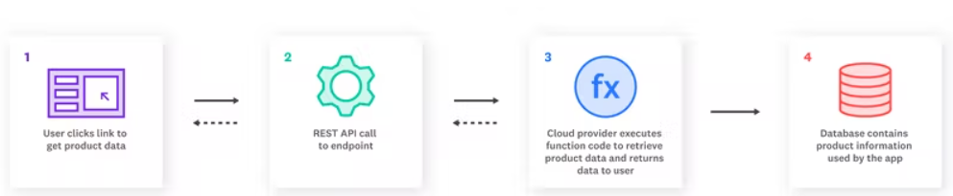
Image 2- Use case for Serverless architecture
Reference: https://www.datadoghq.com/knowledge-center/serverless-architecture/

Advantages of using serverless architecture

Decomposing drives better observability

With serverless, you break down applications into smaller and smaller pieces, known as decomposition. By doing so, you’ll gain better observability across the application.

With smaller pieces, the knowledge necessary to make changes or create fixes is smaller.

Serverless is event-based

Serverless uses an event-based system versus stream-based

With event-based architecture, each subpart of the application is independent. Events trigger one another. In stream-based, there are connections to each service. If there is a failure, it just impacts that event, not the entire log.

Faster deployments, greater flexibility, and accelerated innovation

Speed is often a contributing factor in choosing to use a serverless architecture. You can rapidly deploy apps in hours because there’s no infrastructure construction to weigh you down. With faster deployments also comes ease in scalability.

By using such an agile architecture, you can be very flexible in your releases. Because it’s a quicker process, you can accelerate innovation.

This flexibility is especially valuable in situations where pivoting is urgent. These types of scenarios are playing out all over the world in response to the pandemic. Organizations have to change their focus to meet emerging needs. This could be internal with a move to remote work. Another example is the adoption of customer-facing applications like those of retailers and restaurants.

Reducing architecture costs

Being serverless, an organization is essentially outsourcing server and database management. You are no longer responsible for the huge investments required for internal architecture administration. Ultimately your use case will define how much you can save.

Focusing more on UX

If your applications have end users, which they probably do, they have high expectations around digital experiences. If architecture is no longer a concern, it leaves more time to work on the user experience (UX). You can’t afford to not invest in the user interface, so serverless can provide you with a way to reallocate resources.

Limitations of serverless architecture

Long-running application inefficiencies

Running workloads, which are long-running, could be more costly on serverless. Using a dedicated server is often more efficient.

Third-party dependency

Serverless architecture requires you to be reliant on your provider. You don’t have full control, and changes may impact you without notice. The platform’s availability is subject to its terms.

Cold starts

A “cold start” occurs when a platform must initiate internal resources. It may take some time for your serverless architecture to handle that first function request. You can avoid a “cold start” by ensuring the function remains in an active state. You do this by sending requests to it periodically.

References
- https://newrelic.com/blog/best-practices/what-is-serverless-architecture
- https://www.baeldung.com/cs/serverless-architecture
- https://www.redhat.com/en/topics/cloud-native-apps/what-is-serverless
- https://www.datadoghq.com/knowledge-center/serverless-architecture/

